Create a new instance by selecting the launch instances button  


Select the MS Server 2019 Base

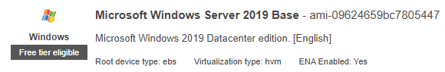

Select t2.micro tier





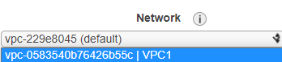



  
  
Once the instance is launched, Rename it so you know which is which.



Ensure that both he Windows Server and the Doner are stopped

Go to Volumes  


You should see something like this  
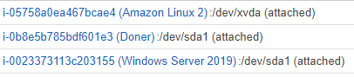  
  
Right click on Windows Server 2019 and click detach volume  
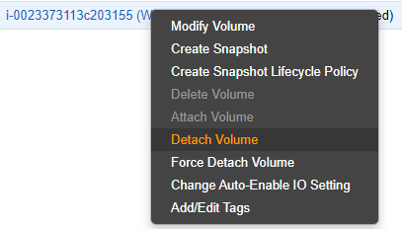  
Select YES, Detatch

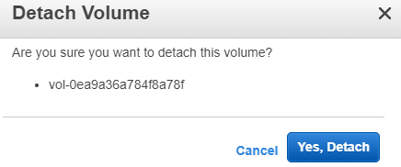

Refresh the page  
Right click on the volume again and attach it to the Doner instance



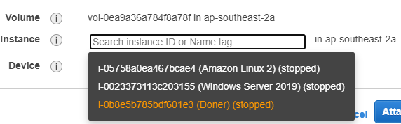

Click attach  
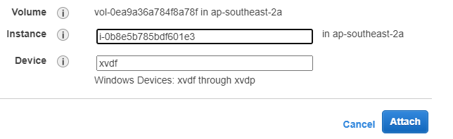

Go back to the EC2 Dashboard and turn on the Doner instance

Right click on it again and click connect  
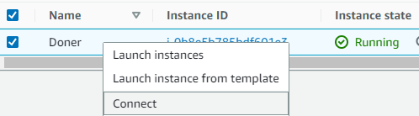

Select the RDP Client Tab  


Click Get Password  


Browse to the KeyPair.pem file that was provided in collaborate  


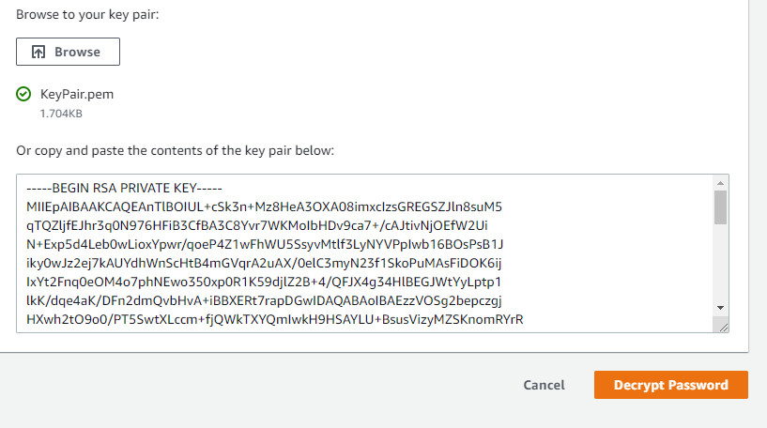

Click Decrypt Password  


Copy the password  
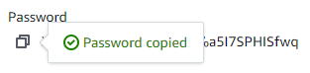

Download the Remote Desktop File  


Open the RDP file and click connect  


Enter your password that was decrypted  
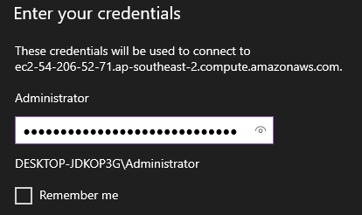

Trust the certificate  
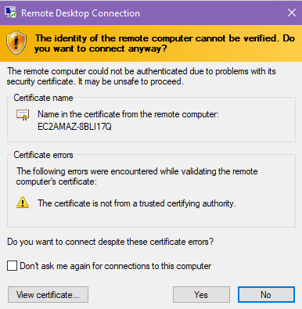

You should now be logged into the RDP session

Open internet explorer  


Turn off windows defender smart screen  
Navigate to the following:  
<https://s3.amazonaws.com/ec2rescue/windows/EC2Rescue_latest.zip?x-download-source=docs>  
  
Save it to your desktop  
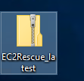

Open the zip folder and open EC2Rescue.exe  
And select Extract All  
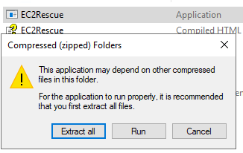

Click Extract  
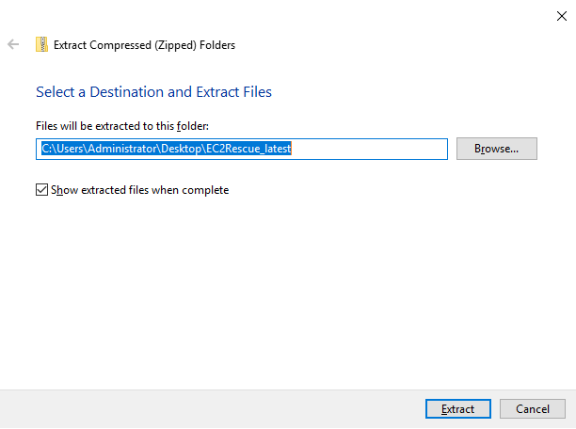  
Now click on the EC2 Rescue.exe application again to open it.

Agree to the terms  
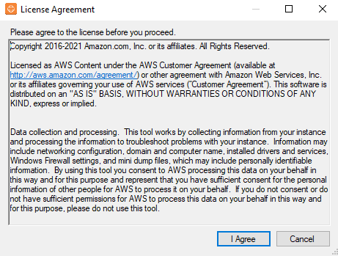  
  
  
  
Click Next on the welcome screen  
Select Offline Instance

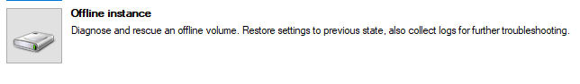

Select the disk that is offline and click next, and confirm the selection

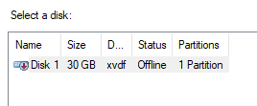

Click Diagnose and Rescue

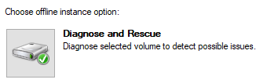

You should see a summary of issues  
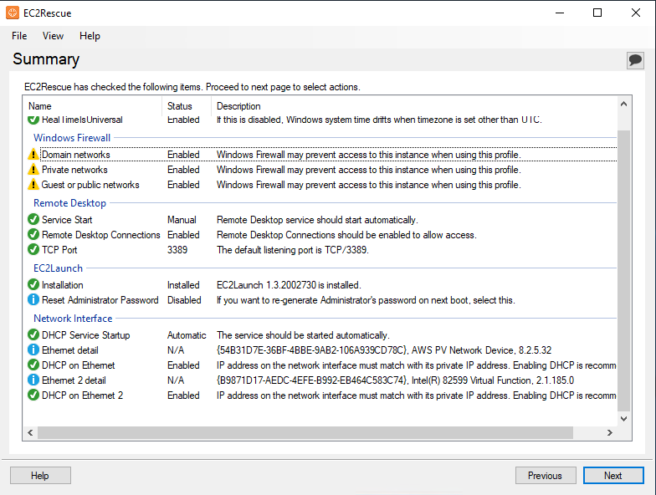

Click Next  
Select all options  
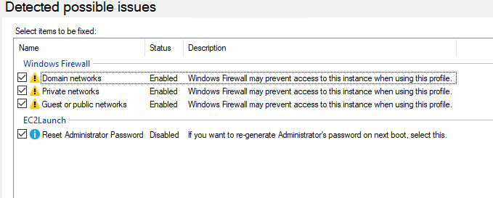

Click Next and Confirm the Rescue  
  
IF THE PASSWORD RESET FAILED, RUN IT AGAIN!  
  
  
  
  
  
Shutdown the instance and use the previous steps to detatch and reattach the drive from the doner instance back to the windows server 2019 instance.   
  
Ensure you set the Device location to /dev/sda1  
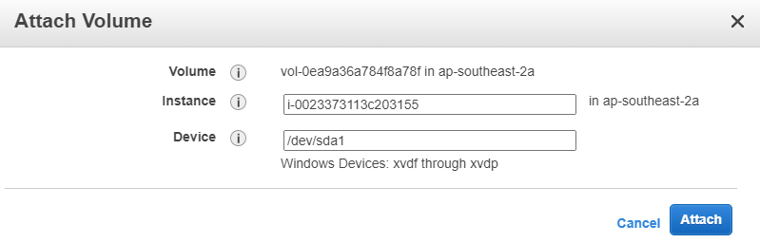

Start the Windows server 2019 instance

Use the same steps above to decrypt the new password for Windows Server 2019